Seng 440 Final Project Progress Report

Shuyi Yu V00910366 [shuyiyu@uvic.ca](mailto:shuyiyu@uvic.ca)

Samuel Gao V00891163 tianleigao@uvic.ca

# Specifications of Design:

* Image Size: 640*480 pixels
* The design involves the implementation of color space conversion from RGB to YCC using only integer arithmetic and saturating arithmetic in an ARM virtual machine.

# Blueprints of Design:

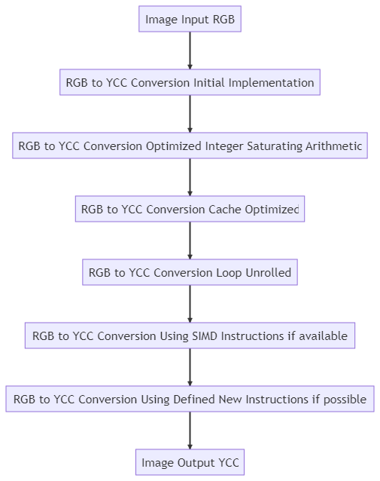

# Processor Used:

The project will run on the provided ARM virtual machine.

# Work Plan and Challenges:

Possible methods of optimization:

## Using Integer and Saturating Arithmetic:

The algorithm will be modified to use only integer arithmetic and saturating arithmetic, replacing any floating point calculations.

## Cache Optimization:

The algorithm will be optimized to minimize cache misses. This may involve techniques like loop blocking or reordering memory accesses to improve locality.

Properly optimizing the algorithm to minimize cache misses will require a good understanding of how the cache on the virtual machine works.

## Loop Unrolling:

To improve speed, loops in the algorithm could be unrolled. This will reduce the overhead of loop control instructions but may also increases code size.

## Using SIMD Instructions:

SIMD instructions could be used to process multiple pixels at once, further speeding up the algorithm.

## Testing and Debugging:

Throughout the process of modifying and optimizing process, rigorous testing will be needed to ensure the algorithm is still correct. This will involve testing the algorithm on a variety of different images and comparing the output to the original implementation of the YCC to RGB conversion.

# Questions:

* What is the best approach to measure the effectiveness of each optimization technique?
* Should we measure the runtime before and after each optimization, or just observe the total runtime of the program?
* How to convert picture file format to input format that is accepted by the provided functions?